Case 4-A84-ME-Jerusalem-Hexagonal Jug-Jewish symbols-Late 6th to early 7th century CE

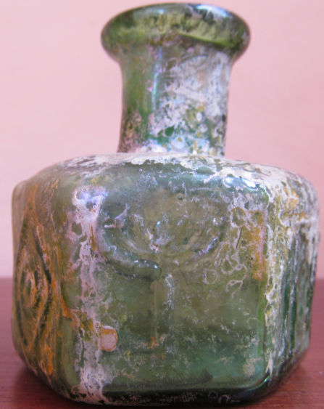 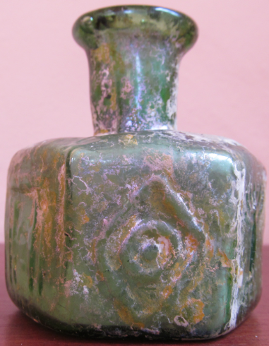 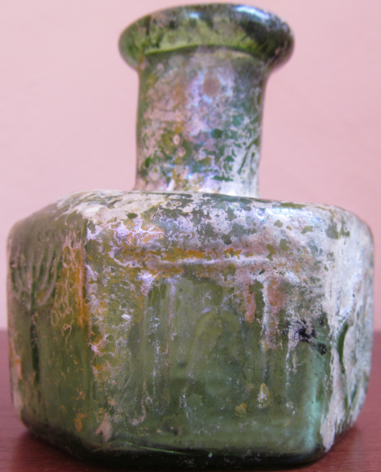

Figs. 1-3. Jerusalem-Hexagonal Jug-Jewish symbols-Late 6th to early 7th century CE

**Case no.: 4**

**Accession Number: A84**

**Formal Label:**

**Display Description:**

This hexagonal jug has four panels with Jewish motifs, two menorah and two temple columns. The remaining two panels are lozenges enclosing “circles with centers.” “The visible feature that ties together the workshops that produced jugs and flasks of this kind is the lozenge-shaped motif that is so often interleaved between the more diagnostic patterns of their decoration whether the latter are floral, Jewish or Christian. But they also share a distinct technological feature that sets them apart from all other kinds of mold-blown vessels. These six-sided vessels were created from a pair of three-faced molds, each with relief designs stamped onto their inner walls so that the decoration is stamped into the glass’s surface rather than raised from it. Wherever its innovation in glassmaking originated, it did not survive the turmoil caused by the foreign intrusions into Judea and the neighboring provinces that occurred in the early part of the seventh century A.D.” (Fleming 1999: 130).

This type of a small jug with Jewish symbols was probably sold in Jerusalem as a souvenir for visiting the temple and it was probably filled with some holy water used in the rituals attended.

**LC Classification:** NK.5107.3

**Date or Time Horizon:** Late 6th to early 7th century CE

**Geographical Area:** Jerusalem, Judea

**GPS coordinates:** 31º46'5.95" N 35º12'49.36" E

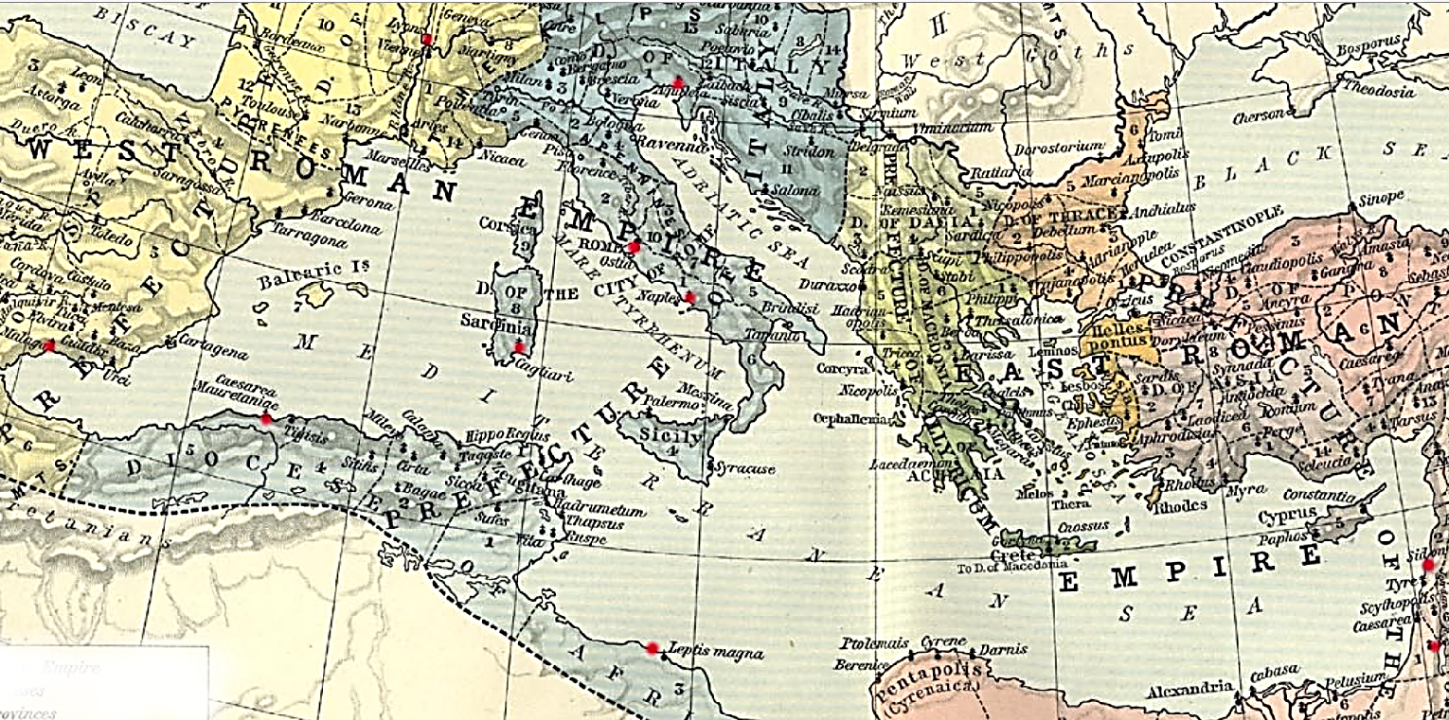

**Map,** Roman Empire, 533-600. Red markers indicate diffusion of Sidonian glassblowing. From http://users.clas.ufl.edu/ufhatch/pages/03-Sci-Rev/SCI-REV-Home/Historical-Research/maps/shepherd-c-052.jpg

**Cultural Affiliation:** Sidonian (Phoenician)

**Medium:** Blown impressed glass

**Dimensions:**

Height: 7.5 cm

Inner Diameter (rim): 2.2 cm

Outer Diameter (rim): 3 cm

Maximum Diameter: 6 cm

**Weight:** Weight: 80 gm

**Condition: original**

**Provenance:** Ex-Touma Dabbah Collection

**Discussion:**

On the eastern borders of the Roman Empire, according to Pliny ca 79 CE (*Historia Naturalis* 36), glassblowing (*flatu figurare*, "shaping by breath") was developed by the Sidonians of the Phoenician Pentapolis.

Glassblowing diffused because of factors political, legal and economic (see Fleming 1999). Politically, Augustus ended a century of civil strife in Italy and created a network of pacified provinces. Legally, Augustus ushered in an era of speedy and safe travel under *Pax Romana* that protected citizens of Rome from Syria to Spain. Economically, Italy experienced a boom that attracted and invigorated entrepreneurialism among artisans and merchants.

Consequently, manySidonian glassblowers immigrated to Italy, established a *vicus vetrarius* or “glassworkers’ quarter” in the vicinity of the Roman Porta Capena in the heart of the Empire (M. Bacchelli et al. 1995) and thereby introduced glassblowing to Romans (Stern 1995, 68-69). Other Italian ateliers were established in Ticino (Biaggio 1991), Naples (Campania; Stern 1976) and Aquileia (Calvi 1991; Scatozza Höricht; Calvi 1968).

Glass-blowing trade expanded to Switzerland (Avenches), to Gaul (*Lugdunum*, i.e., Lyon and Saintes; Nenna 1997; Hochuli-Gysel 1992; B. Velde and A. Hochuli-Gysel 1996), Corsica (Cagliari; Canivet, 1969: fig 15), to the south of the Iberian Peninsula (Price 1987), Libya (Tripoli; Aurigemma 1958, pl.15, fig. 19), and Roman-Berber North Africa (*Caesarea Mauretaniae*, i.e., Tipaza; Lancel 1967).

**References:**

Aurigemma, Salvatore. 1958. *Un Sepolcreto Punico-Pomano sotto il ‘Forte della Vite’ o ‘Forte nord-Ouest’ in Tripoli (Libia)*. Tripoli: Department of antiquities, Administration of Tripolitania.

Bacchelli, M. et al. 1995. “Nuove scoperte sulla prove- nienza dei panelli in opus sectile vitreo della collezione Gorga.” In *Atti del 2 Convegno dell' Associazione Italiana per lo Studio e la Conservazione del Mosaico, Rome, 5-7 December 1994*. Bordighera, pp. 447-66.

Biaggio Simona, S. 1991. I vetri romani provenienti dalle terre dell' attuale Cantone Ticino (Locarno 1991*); Helvetia Archeologica* 22 (1991) 78-143.

Calvi, M. 1968. *I vetri romani del Museo di Aquileia*. Aquileia: Museo di Aquileia.

Calvi, M. 1991. “Arte vetraria Ticinese e arte vetraria Aquileiese: raffronti e analogie," *Helvetia Archeolgia* 22: 133-43.

Canivet, M.T.F. 1969. “I Vetri de Cornus conservati al Museo di Cagliari,” *Journal of Glass Studies* 11: 19-26.

Fadić, Ivo. 1997. *Trasparenze imperiali Vetri romani dalla Croazia [Dalmatia],* exhibition catalogue. Rome: Palazzo Barberini; Milano: Skira.

Fleming, Stuart J. 1999. *Roman glass: reflections on cultural change*. Philadelphia: University of Pennsylvania Museum.

Giacchero, M. 1974. *Edictum Diocletiani et Collegarum de pretiis rerum venalium*. Genova : Istituto di storia antica e scienze ausiliarie.

Goitein S.D. 1967. *A Mediterranean Society 1: Economic Foundations.* Berkeley: University of California Press.

Hochuli-Gysel, A. 1992. “Römisches Glas aus dem Südwesten von Frankreich,” *Annales du 12e Congrès de l'Association internationale pour l'histoire du verre, Vienne (Wien) 26 - 31 août 1991 12, 1991* (Amsterdam), pp. 79-88.

Isings, C. 1957. *Roman Glass from Dated Finds*. Archaeologica Traiectina 9, Groningen.

Lance, Sergel. 1967.*Verrerie antique de tipasa: ouvrage publié avec le concours du conseil de la récherche scientifique en algerie, avec l' autorization du bureau des antiquites de l' algerie*. Paris:  Édition-Diffusion de Boccard.

Masseroli, Sara. 1998. *Vetro e vetri: preziose iridescenze*.  Milano: Electa.

J. Morel *et a*l. 1992. “Un atelier de verrier du milieu du 1er siècle apr. J.-C. à Avenches,” *Archäologie der Schweiz: Mitteilungsblatt der Schweizerischen Gesellschaft für Ur- und Frühgeschichte* 15: 2-17.

Nenna, M.-D. *et al*. 1997. “L'atelier de verrier de Lyon, du 1er siècle après J.-C., et l'origine des verres ‘romains’,” *Révue d'Archeometrie* 21: 81-87.

Newby, M. and K. Painter, eds. 1991. *Roman Glass: Two Centuries of Art and Invention*. The Society of Antiquaries of London, Occasional Paper 13. London: The Society of Antiquaries of London.

Price, J. 1987. “Glass Vessel Production in Southern Iberia in the First and Second Centuries A.D.: A Survey of the Archeological Evidence,” *Journal of the Glass Studies* 29: 30-39.

Scatozza Höricht, L.A. 1991. "Syrian Elements among the Glass from Pompeii and Herculaneum [Campania]," in Newby, M. and K. Painter, eds. 1991. *Roman Glass: Two Centuries of Art and Invention*. The Society of Antiquaries of London, Occasional Paper 13. London: The Society of Antiquaries of London, pp. 76-85.

Stern, E.M. 1976. "A Small Glass Bottle on Three Pinched Feet [from Campania]," in *Festoen Opgedragen aan A.N. Zadoks-Josephus fitta bij haar zeventigste verjaardag (Scripta Archaeologica Groningana* 6, Groningen), pp. 527-38

Stern, E. M. and Birgit Schlick-Nolte. 1994. *Early Glass of the Ancient World 1600 B.C. - A.D. 50: Ernesto Wolf Collection.* Ostfildern: Verlag Gerd Hatje; New York: Distributed in the U.S.A. by Distributed Art Publishers.

Stern, E. M. 1995. [*The Toledo Museum of Art: Roman mold-blown glass: the first through sixth centuries*](http://www.worldcat.org/title/toledo-museum-of-art-roman-mold-blown-glass-the-first-through-sixth-centuries/oclc/264987943&referer=brief_results). Rome: "L'Erma" di Bretschneider in association with the Toledo Museum of Art.

Stern, E. M. 2001. [*Roman, Byzantine, and early medieval glass, 10 BCE-700 CE: Ernesto Wolf collection*](http://www.worldcat.org/title/roman-byzantine-and-early-medieval-glass-10-bce-700-ce-ernesto-wolf-collection/oclc/48267849&referer=brief_results). Ostfildern: Hatje Cantz; New York: Distributed in the U.S.A. by Distributed Art Publishers.

|  |  |
| --- | --- |
|  |  |

Tatton-Brown, V. 1991. "The Roman Empire". In H. Tait (ed.) *Five Thousand Years of Glass*. London: British Museum Press, pp. 62–97.

van Lith, [Sophia Maria Elisabeth](https://www.amazon.com/s/ref=dp_byline_sr_book_1?ie=UTF8&text=Sophia+Maria+Elisabeth+van+Lith&search-alias=books&field-author=Sophia+Maria+Elisabeth+van+Lith&sort=relevancerank) and K. Randsborg. 1985. "Roman Glass in the West: A Social Study," *Berichten van de Rijksdienst voor het Oudheidkundig Bodemonderzoek* 35 (1985) 413-32 and also as a separate reprint by Rijksdienst voor het Outheidkundig Bodemonderzoek.

Velde, B. and A. Hochuli-Gysel. 1996. "Correlations between Antimony, Manganese and Iron Content in Gallo-Roman Glass," *Annales du 13e Congrès de l'Association Internationale pour l'Histoire du Verre, Pays-Bas*, 13, 1995, pp. 185-91.

Weinberg, Gladys Davidson and the Corning Museum of Glass, eds. 1988. *Excavations at Jalame: site of a glass factory in Late Roman Palestine*. Columbia: University of Missouri Press.

*of a glass factory i*